ICS 103: Computer Programming in C
Handout-17 Topic: Arrays of Strings & Use of break and continue statements.

Objective:

- To know what is arrays of strings and how to use it. ?
- To know use of break and continue statements.

Arrays of strings:

To represent arrays of strings we need two-dimensional arrays. The first-dimension represents the number of strings in the array and the second-dimension represents the length of each string.

Example: #define LEN1 5
#define LEN2 81
char strarray [ LEN1 ] [ LEN2 ] = {“This”, “is”, “ICS103”, “Course”, “LAB”} ;
char str [LEN2] = {“Instructor”} ;

Here the array strarray is an array of 5 strings with the size of each string being 81. Thus

strarray [0] [0] = ‘T’, strarray [0] [1] = ‘h’, strarray [0] [2] = ‘i’,
strarray [0] [3] = ‘s’, strarray[0][4] = ‘\0’;
Similarly, strarray [4] [0] = ‘L’, strarray [4] [1] = ‘A’, strarray [4] [2] = ‘B’, strarray[4][3] = ‘\0’.

The string arrays can be read by using gets ( ) and printed by using puts ( ) inside a for loop as

#include<stdio.h>
#include<string.h>
void main()
{
#define LEN1 5
#define LEN2 81

char strarray [ LEN1 ] [ LEN2 ] ;
int i ;
printf("Please Input 5 strings (Not having more than 80 characters)from Keyboard ");
for ( i = 0 ; i < 5 ; ++i )
{ printf ("\nEnter the string number %d : ", i+1 ) ;
gets ( strarray [ i ] ) ;
puts ( strarray [ i ] ) ;
}
} // end of main

Sample Output:

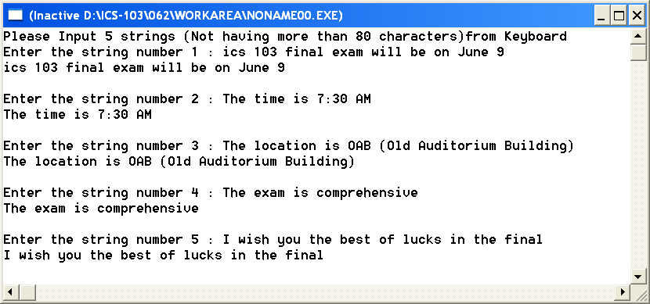

/* This program creates an array of strings and performs various string operations on them*/
#include <stdio.h>
#include <string.h>
#define NUM 24
#define LEN 20

int main(){
int i, found = 0;
char str[20];
char names [NUM][LEN] = {{'I','s','s','a','\0'}, "Saad", "Hani", "Aqeel", "Adel", "Muhannad",
"Muhammad", "Muhammad", "Abdulmohsin", "Khalil", "Ahmad",
"Thamer", "Musab", "Yahya", "Majed", "Hamad", "Saud", "Said", "Hisham",
"Khaled", "Nayef", "Marwan", "Abdulrahman","Abdullah"};
printf("The length of the names are:\n");
for(i = 0; i < NUM; i++){
printf("%4d%12s of length %d\n", i+1,names[i], strlen(names[i]));
}

printf("\nEnter a name to search in the list: ");
gets(str);
for(i = 0; i < NUM&&!found; i++){
if(strcmp(names[i], str) == 0){
found = 1;
}
}
if(found)
printf("%s is in the list at row %d",str,i);
else printf("%s is not in the list.\n", str);
return 0;
}
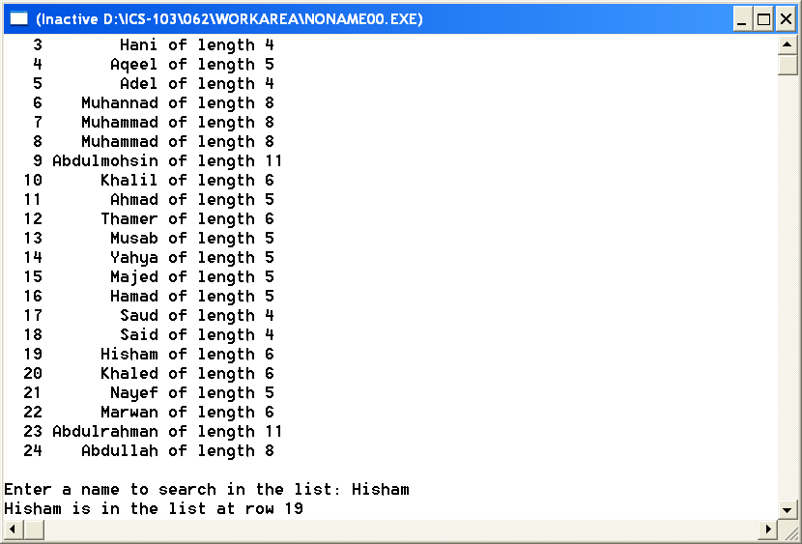

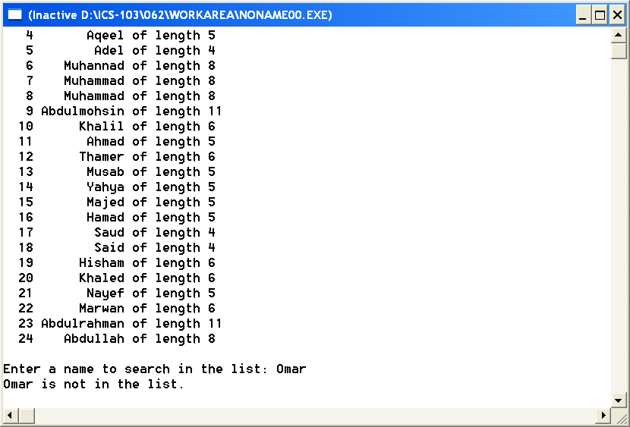

Use of break & continue statements:

#include<stdio.h>
void main()
{
int i;
for(i=1;i<=10;i++)
{
if(i==5)
break;
printf("%d\n",i);
}
printf("I hope that you learned something from the course");
} // end of main

Sample Output:

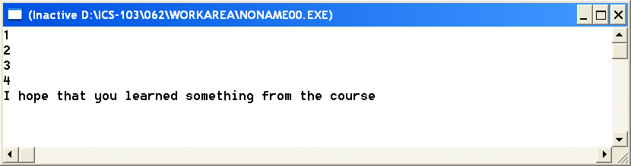

Use of Continue statement :

#include<stdio.h>
void main()
{
int i;
for(i=1;i<=10;i++)
{
if(i==5)
continue;
printf("%d\n",i);
}
printf("I hope that you learned something from the course");
} // end of main

Sample Output:

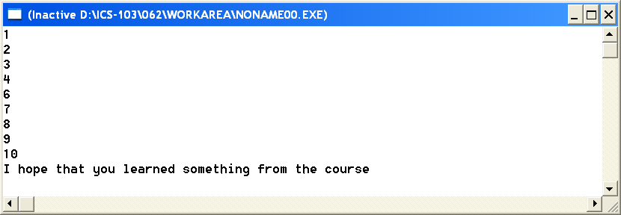

#include <stdio.h>
main()
{
int x ;
for ( x=0 ; x<=20 ; x++) {
if (x%2) continue;
printf("%d\n" , x);
}
}

